Date: 03.07.2020
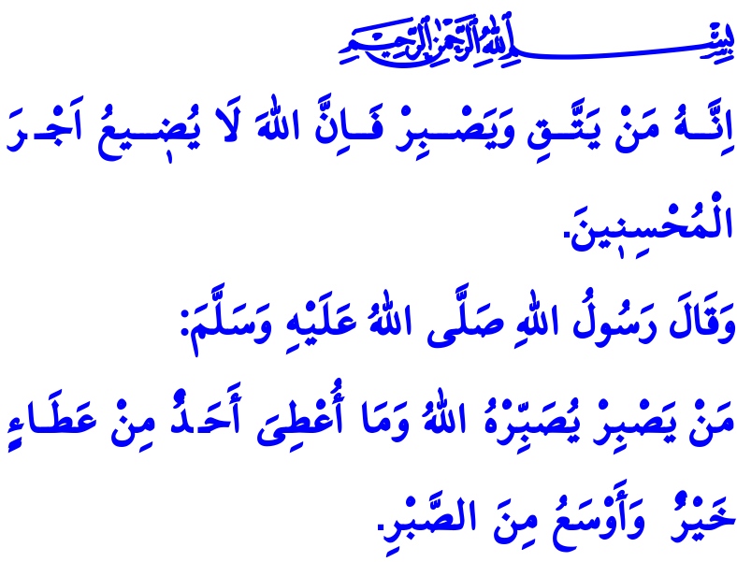
AFTER PATIENCE COMES EASE AND RELIEF
Honorable Muslims!
Every human being is, in a manner of speaking, a passenger in this worldly life. In this temporary and mortal life, whoever comes in goes out one day. The path to paradise for each of us passes through ups and downs, and joys and hardships. As we continue our journey while enduring the sorrows and at the same time keeping up our hopes, our Lord (swt) grants us a unique blessing that saves our heart from haste, our tongue from complaints, and our body from malevolent conducts. Patience is the name of that blessing.
Dear Believers!
Patience does not mean contempt or apathy. It does not mean weariness or helplessness either. It means forbearance, continuing worship and obedience to Allah with the awareness of servitude to Him. It means endurance, breasting numerous tests and trials of the world. It means discernment, making the effort to carry on living without heeding the whispers of the Satan and falling for the desires of the nafs. It means resoluteness, demonstrating a moderate and cold-blooded stance against occurrences of unexpected events. It means tawakkul (reliance on Allah): being satisfied and contented with the divine decree after making every effort and taking all necessary measures. And patience means, a requirement of faith, a gate to salvation, and a heavenly treasure.
Dear Muslims!
Sometimes people fail to display patience even in the face of trivial problems. Some other times they lose patience due to great calamities and fall into the swirl of hopelessness. They think their illnesses will never heal, financial problems will not be over, and family problems will not be solved. They are drawn into the delusion that peace, success, and health are far away from them. The good news in the Qur’an, however, is quite clear: “For indeed, with hardship [will be] ease.” Many a grace is hidden in many a trouble. An evil-looking and foul matter may bring about unexpected auspicious and fair outcomes. What matters most is that the servants of Allah should keep their patience and resoluteness. What matters most is that people should keep up the faith that Allah is always with the patient.
Dear Believers!
On one occasion, the Prophet Muhammad (saw) said, “Whoever remains patient, Allah will make him patient. Nobody can be given a blessing better and greater than patience.”
Then, let us know the value of such a rare blessing as patience. Let us keep in mind that Allah will test us with both the existence and lack of something and that every test and trial can be overcome with effort and patience. Let us never give up our hopes that Allah (swt) shall help us and be merciful to us.
As I conclude the khutbah, I would like to share the following verse in the Holy Qur’an, “Whoever fears Allah and is patient, then indeed, Allah does not allow to be lost the reward of those who do good.”

Sharh, 94/5-6.
Muslim, Zakat, 124.
Yusuf 12/90. General Directorate of Religious Services

